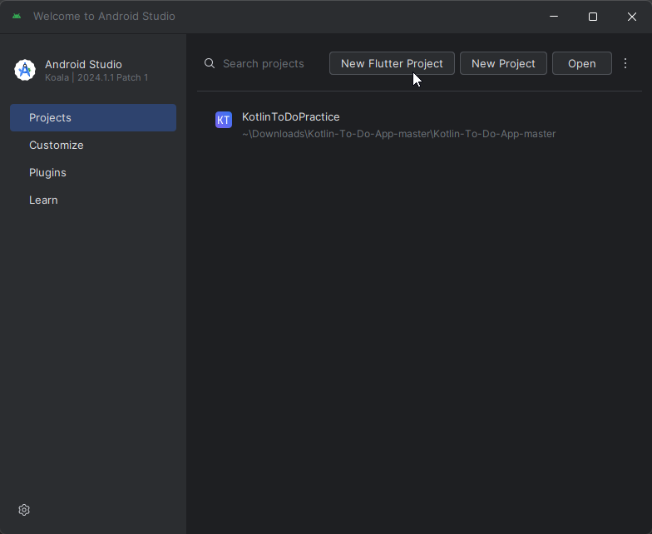

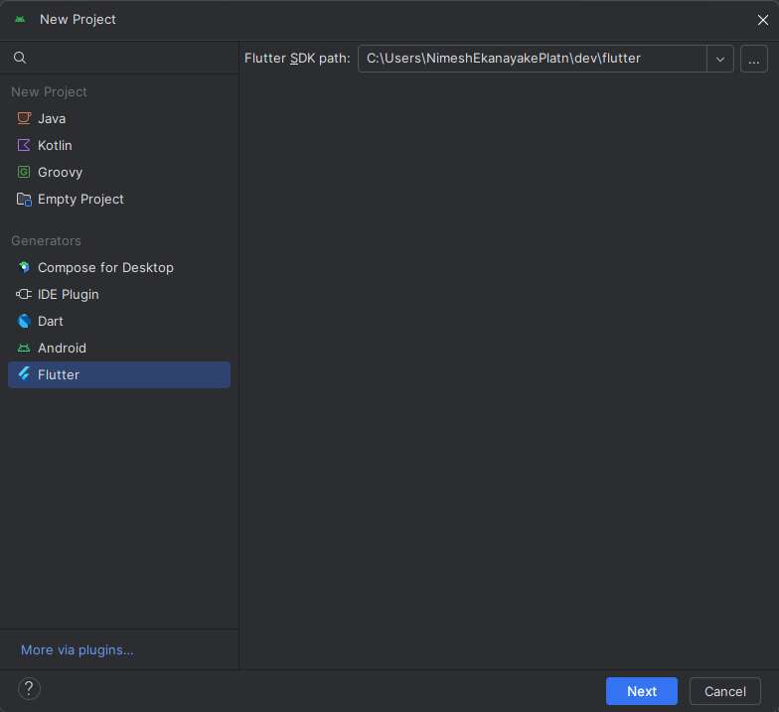

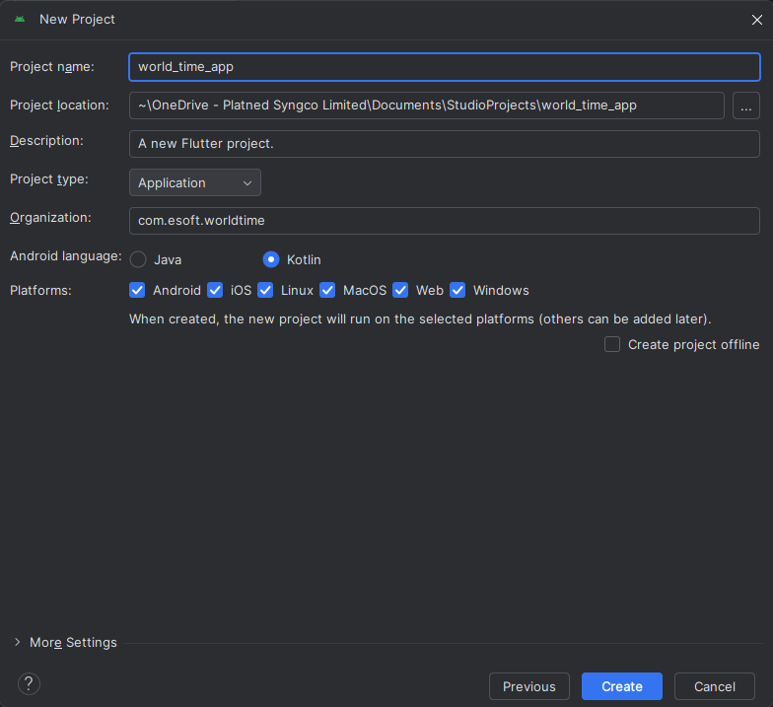

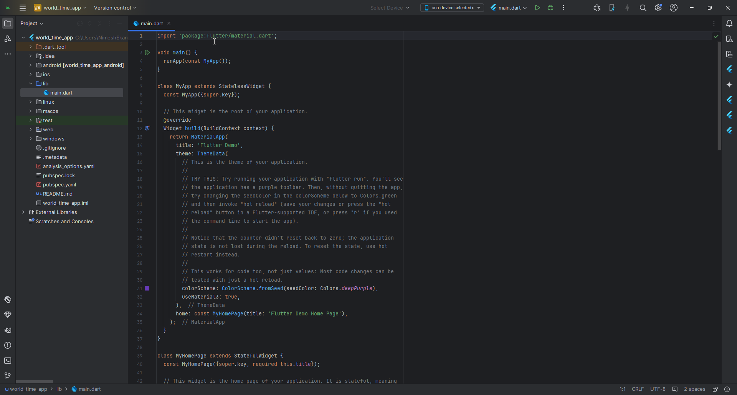

|  |
| --- |
| main.dart |
| import 'package:flutter/material.dart';  void main() {  runApp(  const MaterialApp(  home: Text('Esoft Metro Campus'),  )  ); } |

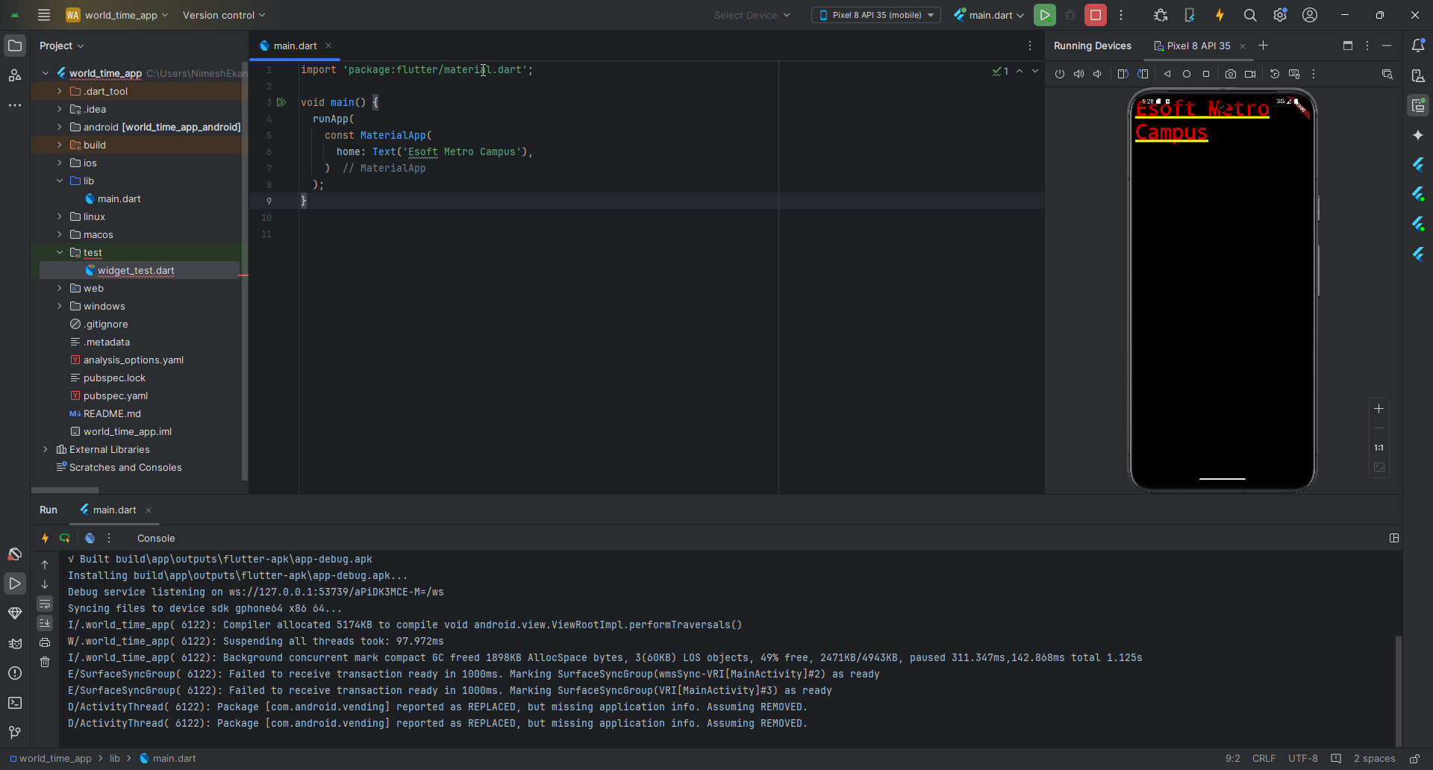

|  |
| --- |
| Main.dart |
| import 'package:flutter/material.dart';  void main() {  runApp(  MaterialApp(  home: Scaffold(  appBar: AppBar(  title: const Text('ESOFT Mobile App'),  centerTitle: true,  ),  ),  )  ); } |

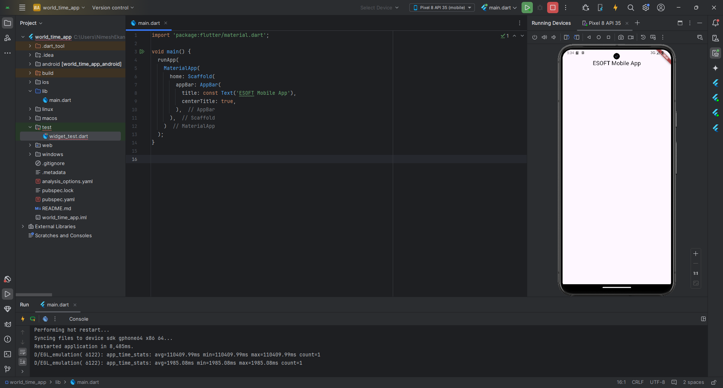

|  |
| --- |
| Main.dart |
| import 'package:flutter/material.dart';  void main() {  runApp(  MaterialApp(  home: Scaffold(  appBar: AppBar(  title: const Text('ESOFT Mobile App'),  centerTitle: true,  ),  body: const Center(  child: Text('Hello Students!'),  ),  ),  )  ); } |

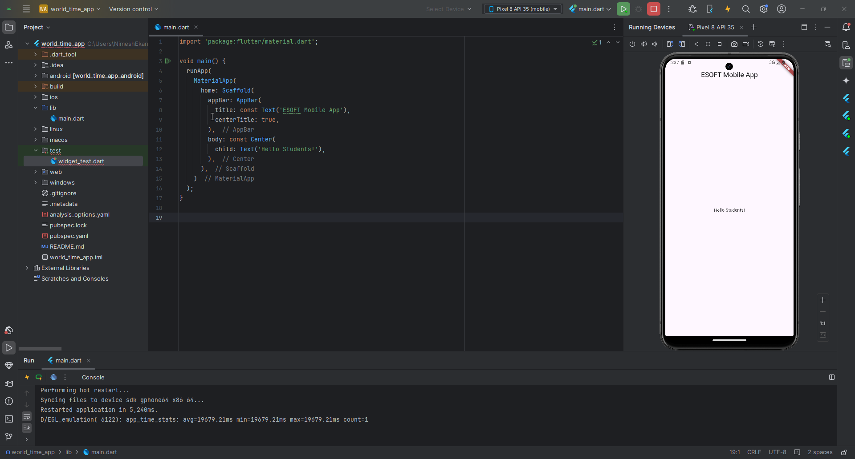

|  |
| --- |
|  |
| import 'package:flutter/material.dart';  void main() {  runApp(  MaterialApp(  home: Scaffold(  appBar: AppBar(  title: const Text('ESOFT Mobile App'),  centerTitle: true,  ),  body: const Center(  child: Text('Hello Students!'),  ),  floatingActionButton: FloatingActionButton(  onPressed: () { },  child: const Text('Click'),  ),  ),  )  ); } |

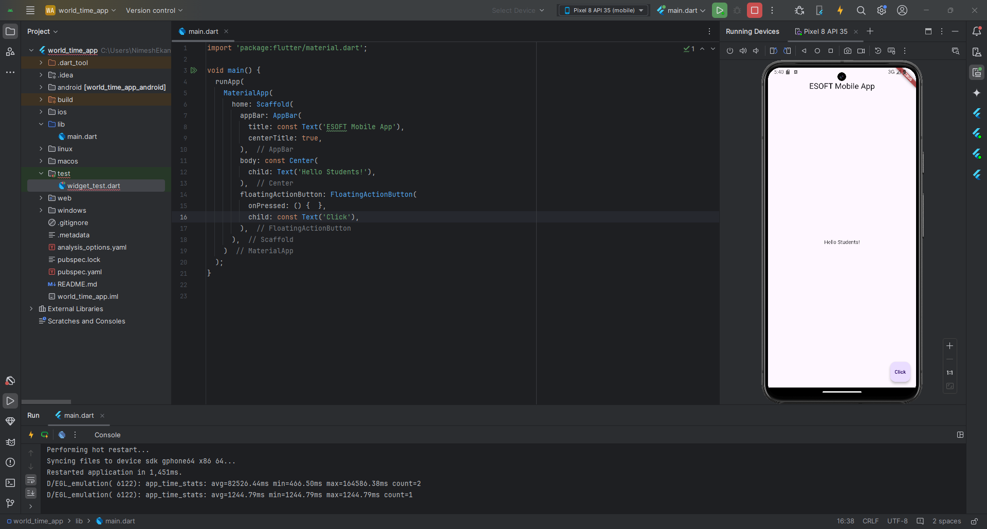

<https://api.flutter.dev/flutter/material/Scaffold-class.html>

|  |
| --- |
|  |
| import 'package:flutter/material.dart';  void main() {  runApp(  MaterialApp(  home: Scaffold(  appBar: AppBar(  title: const Text('ESOFT Mobile App'),  centerTitle: true,  backgroundColor: Colors.*blue*[800],  ),  body: const Center(  child: Text('Hello Students!'),  ),  floatingActionButton: FloatingActionButton(  onPressed: () { },  backgroundColor: Colors.*blue*[800],  child: const Text('Click'),  ),  ),  )  ); } |

<https://m1.material.io/style/color.html#color-color-palette>

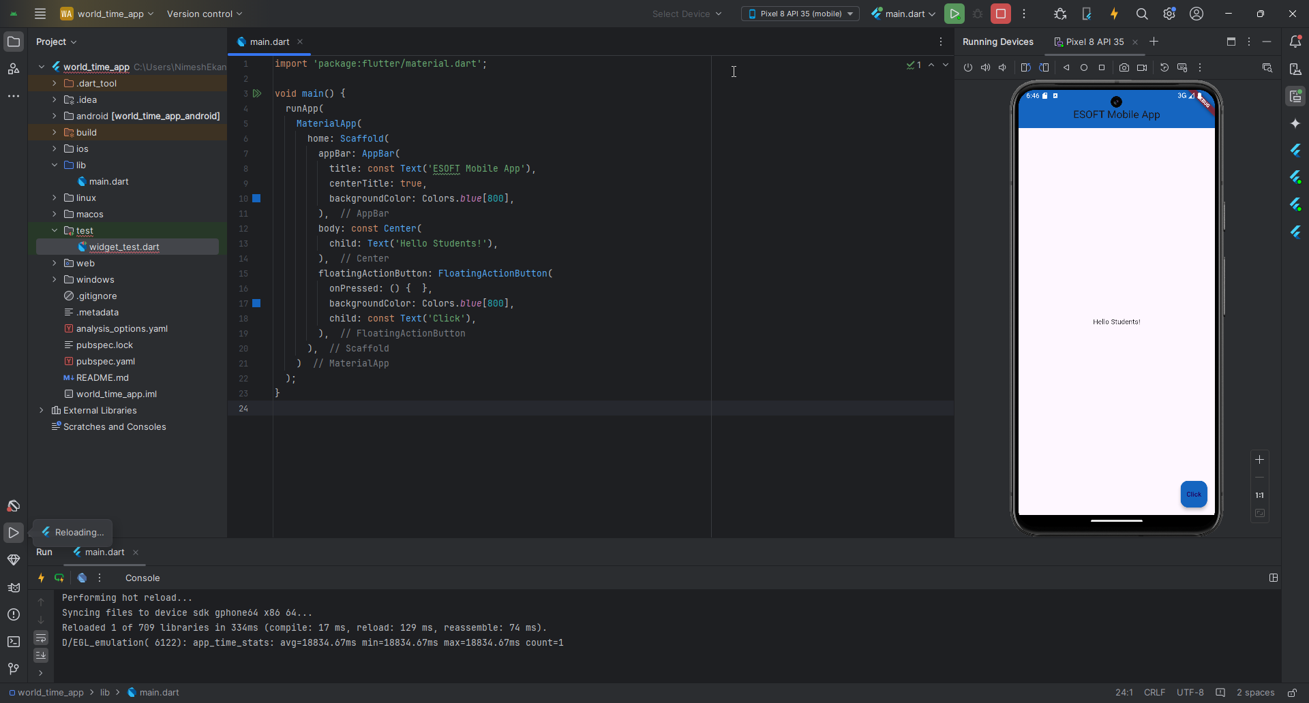

RMB Project > New > Directory

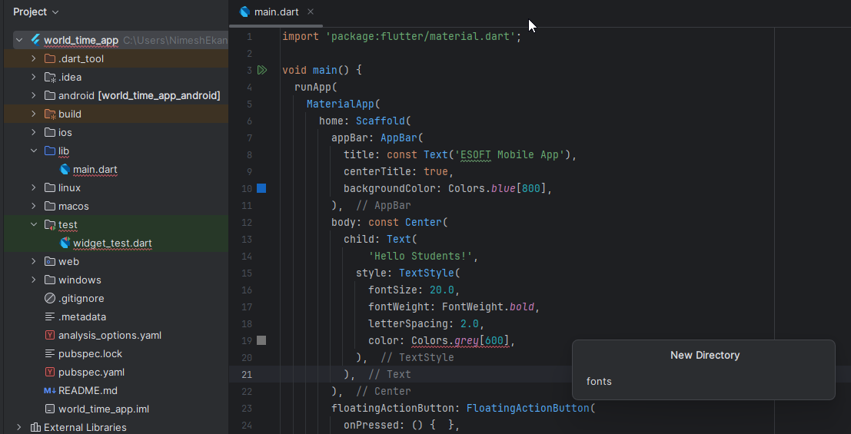

Drag and drop the font to the created directory.

<https://fonts.google.com/specimen/Indie+Flower?query=indie>

|  |
| --- |
| pubspec.yml |
| fonts:  - family: IndieFlower  fonts:  - asset: fonts/IndieFlower-Regular.ttf |

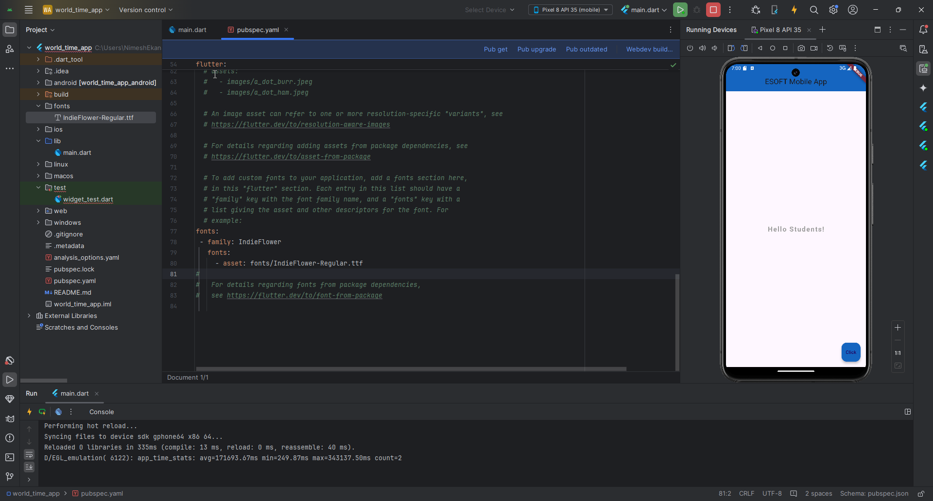

|  |
| --- |
|  |
| import 'package:flutter/material.dart';  void main() {  runApp(  MaterialApp(  home: Scaffold(  appBar: AppBar(  title: const Text('ESOFT Mobile App'),  centerTitle: true,  backgroundColor: Colors.*blue*[800],  ),  body: const Center(  child: Text(  'Hello Students!',  style: TextStyle(  fontSize: 20.0,  fontWeight: FontWeight.*bold*,  letterSpacing: 2.0,  color: Colors.*grey*,  fontFamily: 'IndieFlower',  ),  ),  ),  floatingActionButton: FloatingActionButton(  onPressed: () { },  backgroundColor: Colors.*blue*[800],  child: const Text('Click'),  ),  ),  )  ); } |

Do a Hot Restart

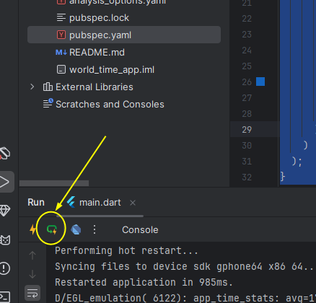

|  |
| --- |
| main.dart |
| import 'package:flutter/material.dart';  void main() {  runApp(  MaterialApp(  home: Scaffold(  appBar: AppBar(  title: const Text('ESOFT Mobile App'),  centerTitle: true,  backgroundColor: Colors.*blue*[800],  ),  body: const Center(  child: Text(  'Hello Students!',  style: TextStyle(  fontSize: 20.0,  fontWeight: FontWeight.*bold*,  letterSpacing: 2.0,  color: Colors.*grey*,  fontFamily: 'IndieFlower',  fontStyle: FontStyle.normal,  ),  ),  ),  floatingActionButton: FloatingActionButton(  onPressed: () { },  backgroundColor: Colors.*blue*[800],  child: const Text('Click'),  ),  ),  )  ); } |

Stateless Widgets and Hot Reload

Type stless > select and enter

*Stateless – the state of the widget cannot change overtime. If we do a change in the code, it will auto-rebuild the app due to the change.*

|  |
| --- |
| main.dart |
| import 'package:flutter/material.dart';  void main() {  runApp(  const MaterialApp(  home: Home()  )  ); }  class Home extends StatelessWidget {  const Home({super.key});   @override  Widget build(BuildContext context) {  return Scaffold(  appBar: AppBar(  title: const Text('ESOFT Mobile App'),  centerTitle: true,  backgroundColor: Colors.*blue*[800],  ),  body: const Center(  child: Text(  'Hello Students!',  style: TextStyle(  fontSize: 20.0,  fontWeight: FontWeight.*bold*,  letterSpacing: 2.0,  color: Colors.*grey*,  fontFamily: 'IndieFlower',  fontStyle: FontStyle.normal,  ),  ),  ),  floatingActionButton: FloatingActionButton(  onPressed: () { },  backgroundColor: Colors.*blue*[800],  child: const Text('Click'),  ),  );  } } |

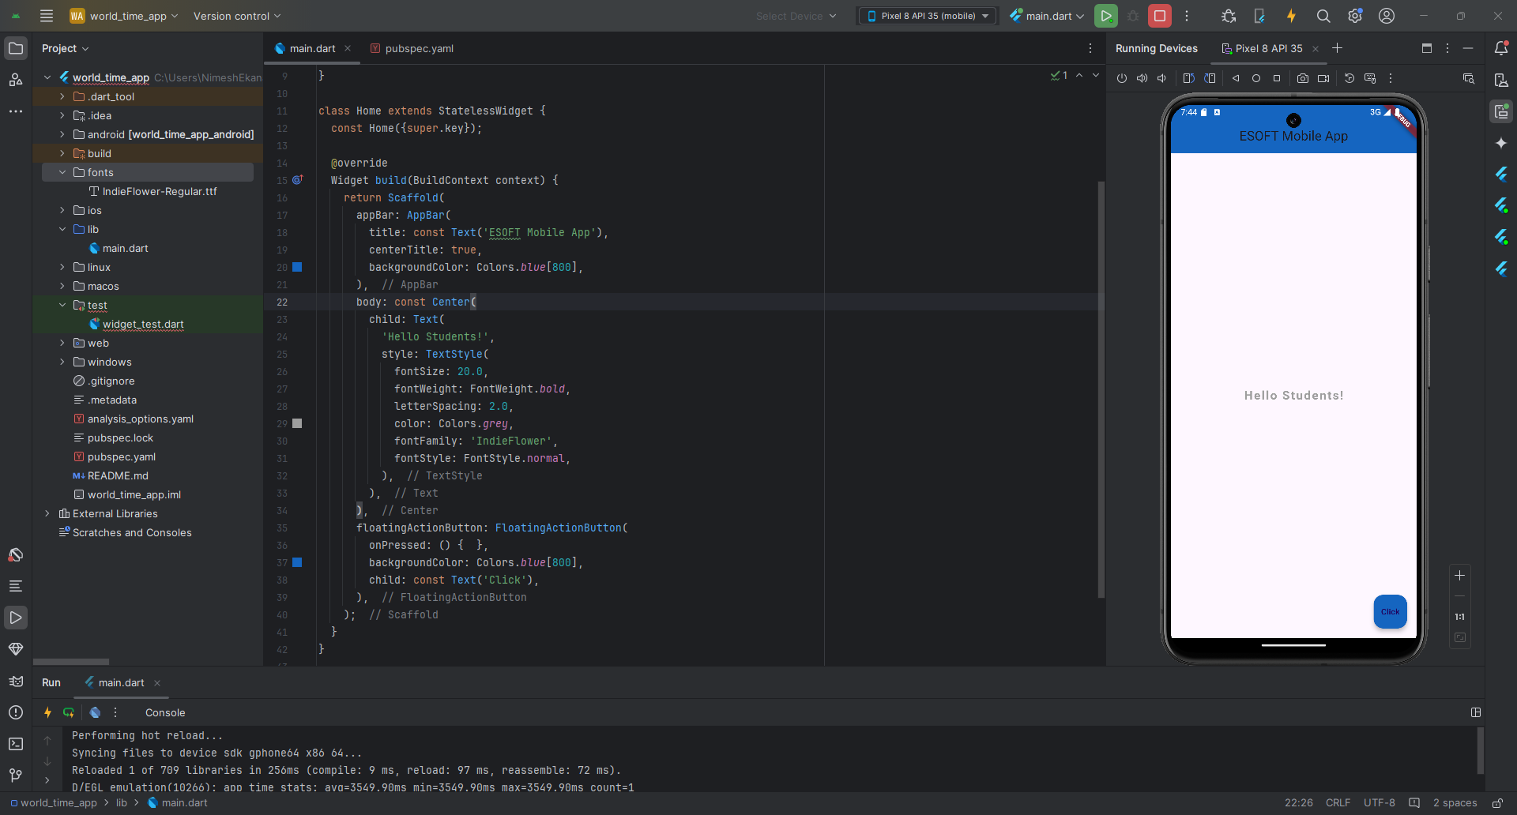

Images and Assets

**Image over network:**

<https://esoft.lk/wp-content/uploads/2023/12/ban.png>

|  |
| --- |
| main.dart |
| import 'package:flutter/material.dart';  void main() {  runApp(  const MaterialApp(  home: Home()  )  ); }  class Home extends StatelessWidget {  const Home({super.key});   @override  Widget build(BuildContext context) {  return Scaffold(  appBar: AppBar(  title: const Text('ESOFT Mobile App'),  centerTitle: true,  backgroundColor: Colors.*blue*[800],  ),  body: const Center(  child: Image(  image: NetworkImage('https://esoft.lk/wp-content/uploads/2023/12/ban.png'),  )  ),  floatingActionButton: FloatingActionButton(  onPressed: () { },  backgroundColor: Colors.*blue*[800],  child: const Text('Click'),  ),  );  } } |

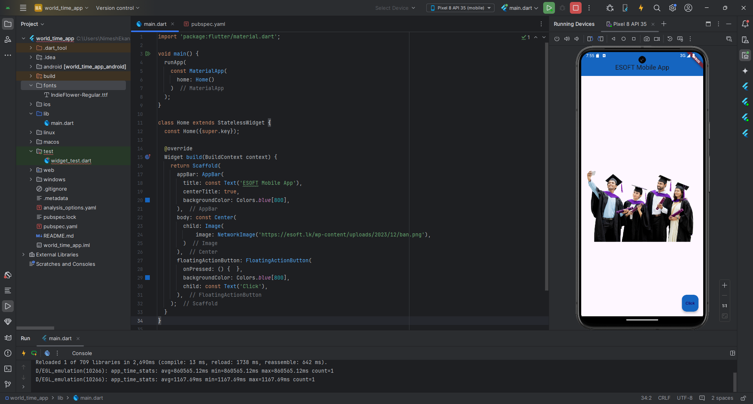

**Image from Asset:**

New Directory:

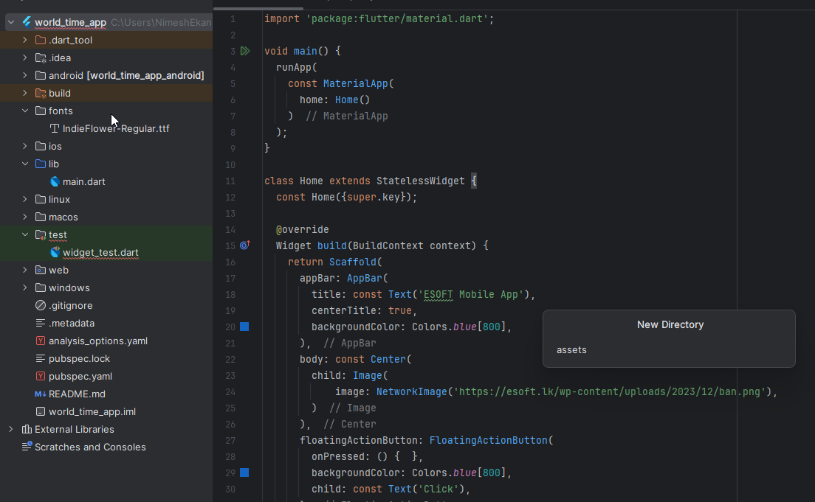

Drag and Drop the images to assets directory.

|  |
| --- |
| pubspec.yaml (2 ways) |
| *# To add assets to your application, add an assets section, like this:* assets:  - assets/AboutEsoft.jpg |
| *# To add assets to your application, add an assets section, like this:* assets:  - assets/ |

|  |
| --- |
| main.dart (2 ways) |
| import 'package:flutter/material.dart';  void main() {  runApp(  const MaterialApp(  home: Home()  )  ); }  class Home extends StatelessWidget {  const Home({super.key});   @override  Widget build(BuildContext context) {  return Scaffold(  appBar: AppBar(  title: const Text('ESOFT Mobile App'),  centerTitle: true,  backgroundColor: Colors.*blue*[800],  ),  body: const Center(  child: **Image(  image: AssetImage('assets/AboutEsoft.jpg'),  )**  ),  floatingActionButton: FloatingActionButton(  onPressed: () { },  backgroundColor: Colors.*blue*[800],  child: const Text('Click'),  ),  );  } } |
| import 'package:flutter/material.dart';  void main() {  runApp(  const MaterialApp(  home: Home()  )  ); }  class Home extends StatelessWidget {  const Home({super.key});   @override  Widget build(BuildContext context) {  return Scaffold(  appBar: AppBar(  title: const Text('ESOFT Mobile App'),  centerTitle: true,  backgroundColor: Colors.*blue*[800],  ),  body: Center(  child: **Image.asset('assets/AboutEsoft.jpg'),**  ),  floatingActionButton: FloatingActionButton(  onPressed: () { },  backgroundColor: Colors.*blue*[800],  child: const Text('Click'),  ),  );  } } |

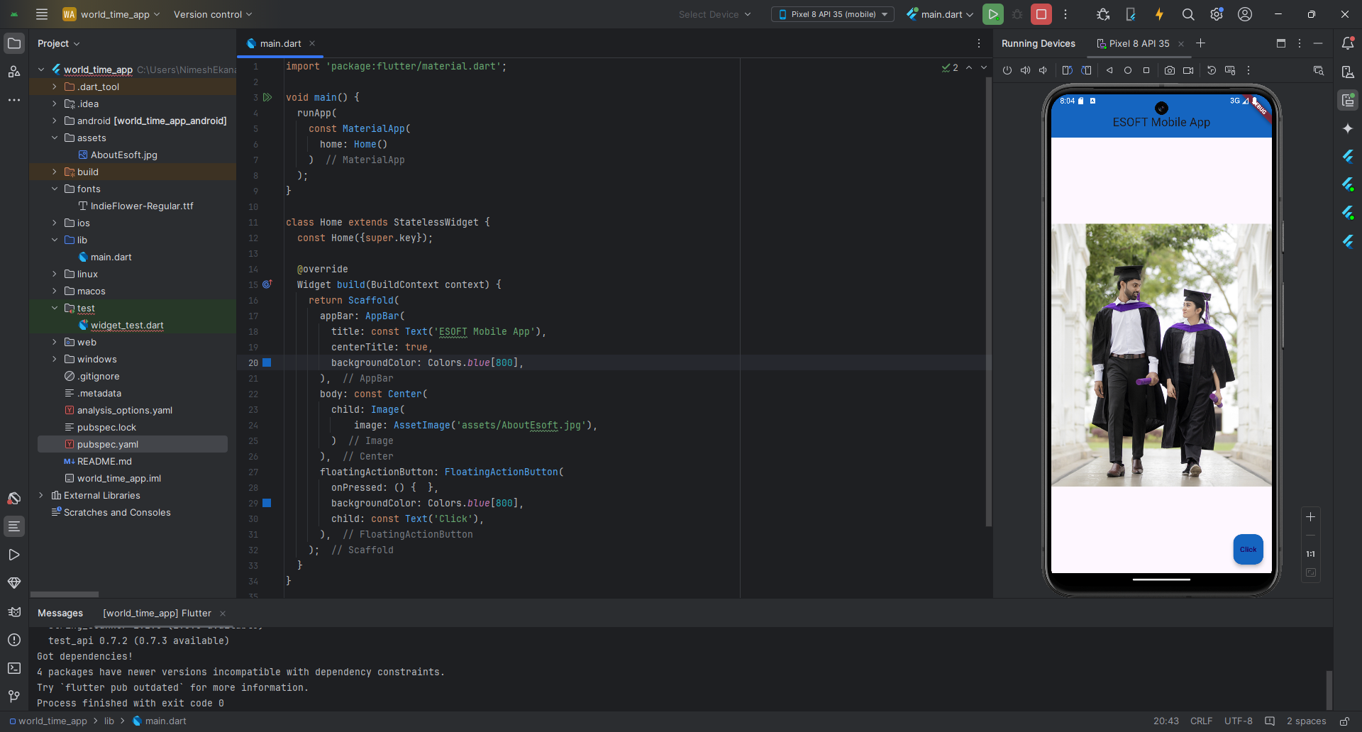

Buttons and Icons

|  |
| --- |
| maint.dart |
| import 'package:flutter/material.dart';  void main() {  runApp(  const MaterialApp(  home: Home()  )  ); }  class Home extends StatelessWidget {  const Home({super.key});   @override  Widget build(BuildContext context) {  return Scaffold(  appBar: AppBar(  title: const Text('ESOFT Mobile App'),  centerTitle: true,  backgroundColor: Colors.*blue*[800],  ),  body: const Center(  child: Icon(  Icons.*school*,  color: Colors.*blueAccent*,  size: 50,  ),  ),  floatingActionButton: FloatingActionButton(  onPressed: () { },  backgroundColor: Colors.*blue*[800],  child: const Text('Click'),  ),  );  } } |

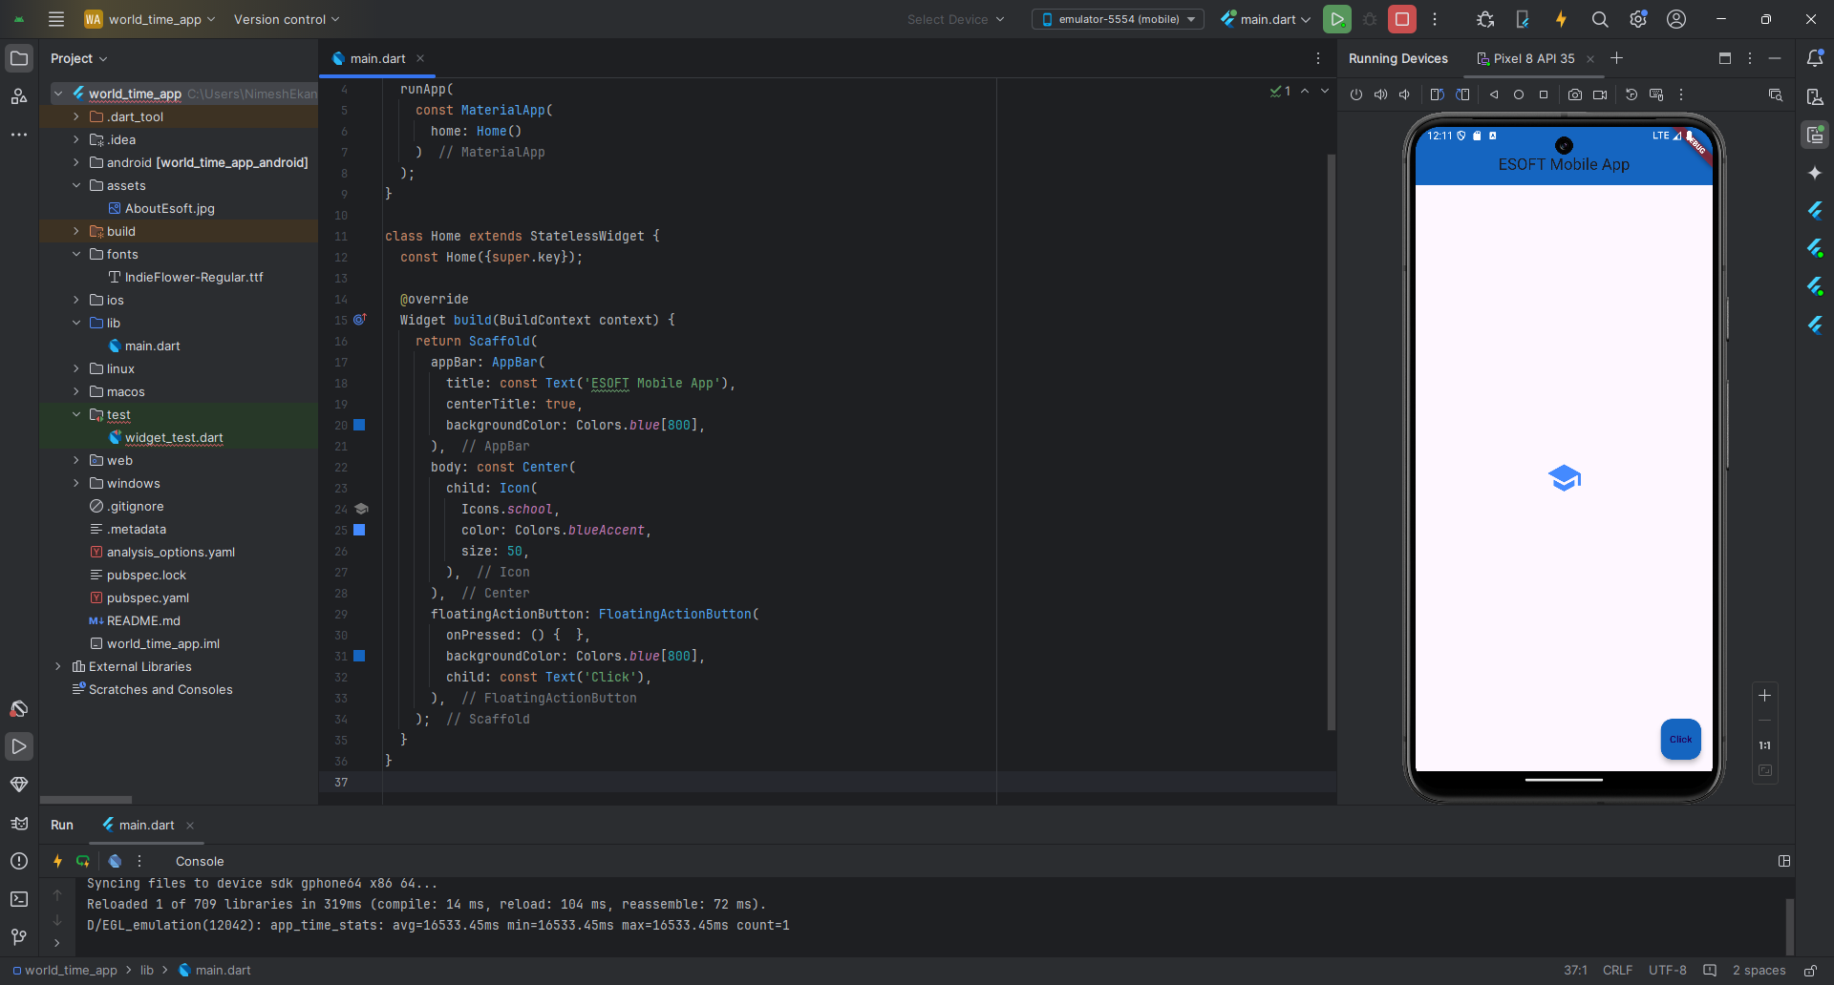

|  |
| --- |
|  |
| class Home extends StatelessWidget {  const Home({super.key});   @override  Widget build(BuildContext context) {  return Scaffold(  appBar: AppBar(  title: const Text('ESOFT Mobile App'),  centerTitle: true,  backgroundColor: Colors.*blue*[800],  ),  body: Center(  child: **ElevatedButton**(  onPressed: () {  print('You Started the Registraion!');  },  child: const Text(  'Register Now'  ),  ),  ),  floatingActionButton: FloatingActionButton(  onPressed: () { },  backgroundColor: Colors.*blue*[800],  child: const Text('Click'),  ),  );  } } |
| class Home extends StatelessWidget {  const Home({super.key});   @override  Widget build(BuildContext context) {  return Scaffold(  appBar: AppBar(  title: const Text('ESOFT Mobile App'),  centerTitle: true,  backgroundColor: Colors.*blue*[800],  ),  body: Center(  child: **TextButton**(  onPressed: () {  print('You Started the Registraion!');  },  child: const Text(  'Register Now'  ),  ),  ),  floatingActionButton: FloatingActionButton(  onPressed: () { },  backgroundColor: Colors.*blue*[800],  child: const Text('Click'),  ),  );  } } |

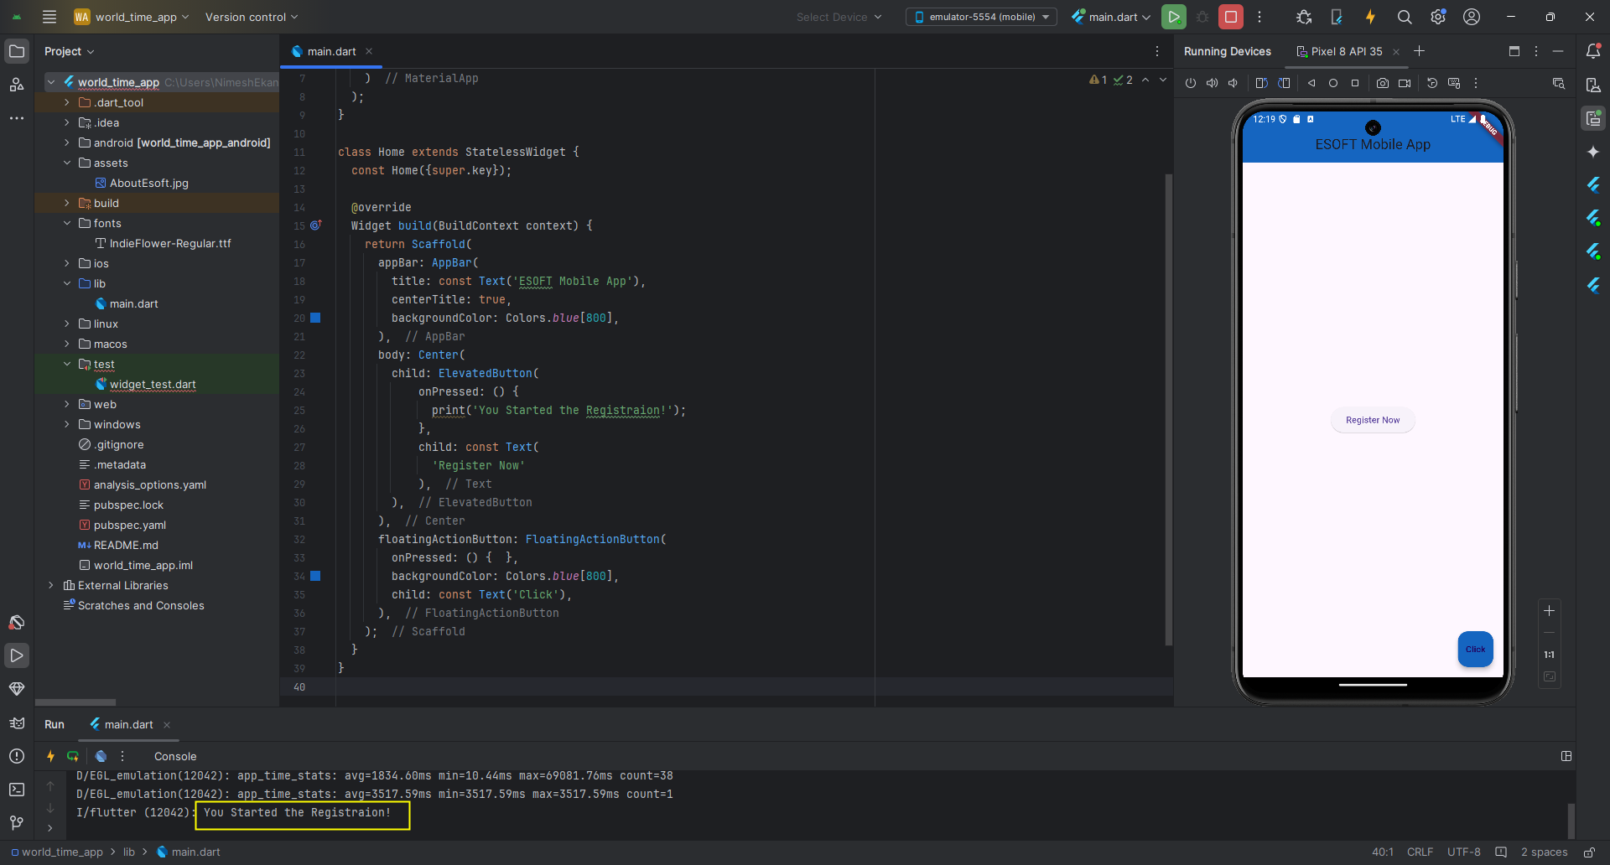

|  |
| --- |
|  |
| class Home extends StatelessWidget {  const Home({super.key});   @override  Widget build(BuildContext context) {  return Scaffold(  appBar: AppBar(  title: const Text('ESOFT Mobile App'),  centerTitle: true,  backgroundColor: Colors.*blue*[800],  ),  body: Center(  child: **ElevatedButton.icon(  onPressed: () {},  icon: const Icon(  Icons.*email* ),  label: const Text('Email Us'),  style: ElevatedButton.*styleFrom*(  backgroundColor: Colors.*blueAccent*,  foregroundColor: Colors.*white*,  ),  ),**  ),  floatingActionButton: FloatingActionButton(  onPressed: () { },  backgroundColor: Colors.*blue*[800],  child: const Text('Click'),  ),  );  } } |

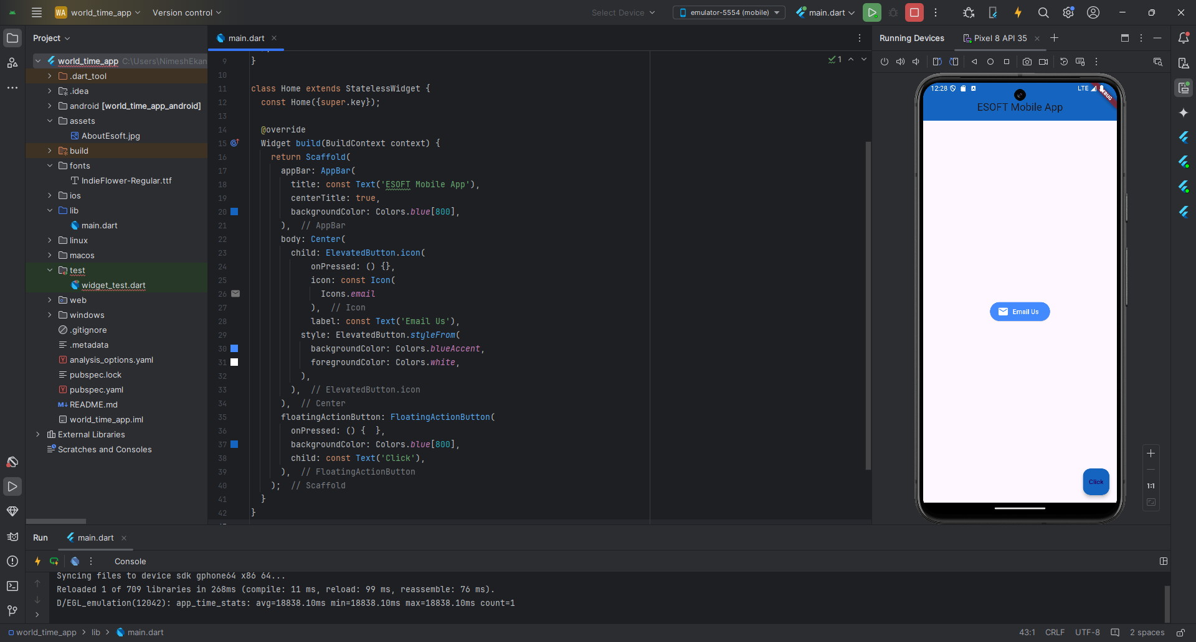

|  |
| --- |
|  |
| class Home extends StatelessWidget {  const Home({super.key});   @override  Widget build(BuildContext context) {  return Scaffold(  appBar: AppBar(  title: const Text('ESOFT Mobile App'),  centerTitle: true,  backgroundColor: Colors.*blue*[800],  ),  body: Center(  child: **IconButton(  onPressed: () {  print('You are calling us...');  },  icon: const Icon(Icons.*call*),  color: Colors.*brown*,  ),**  ),  floatingActionButton: FloatingActionButton(  onPressed: () { },  backgroundColor: Colors.*blue*[800],  child: const Text('Click'),  ),  );  } } |

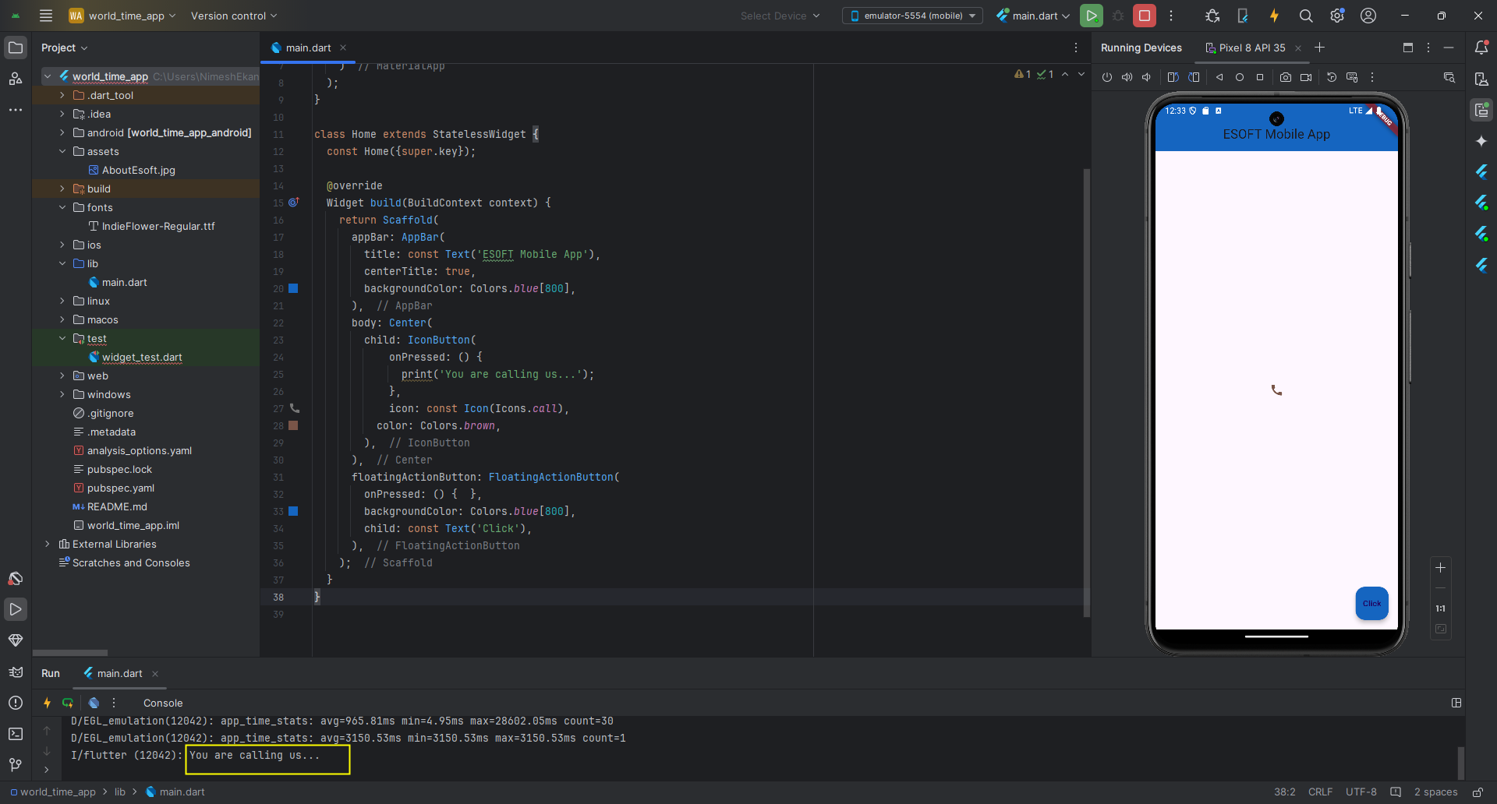

Containers & Padding

|  |
| --- |
|  |
| class Home extends StatelessWidget {  const Home({super.key});   @override  Widget build(BuildContext context) {  return Scaffold(  appBar: AppBar(  title: const Text('ESOFT Mobile App'),  centerTitle: true,  backgroundColor: Colors.*blue*[800],  ),  body: **Container(  color: Colors.*greenAccent*,  ),**  floatingActionButton: FloatingActionButton(  onPressed: () { },  backgroundColor: Colors.*blue*[800],  child: const Text('Click'),  ),  );  } } |

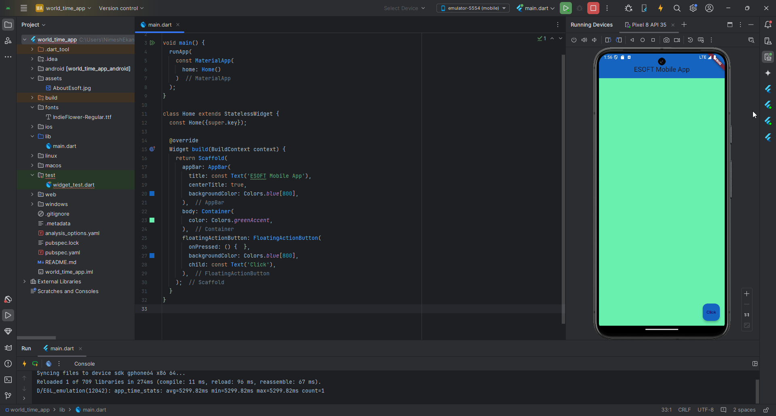

|  |
| --- |
|  |
| class Home extends StatelessWidget {  const Home({super.key});   @override  Widget build(BuildContext context) {  return Scaffold(  appBar: AppBar(  title: const Text('ESOFT Mobile App'),  centerTitle: true,  backgroundColor: Colors.*blue*[800],  ),  body: Container(  color: Colors.*greenAccent*,  **child: const Text('Welcome to ESOFT!'),**  ),  floatingActionButton: FloatingActionButton(  onPressed: () { },  backgroundColor: Colors.*blue*[800],  child: const Text('Click'),  ),  );  } } |

When having a child widget, the container restricts itself to the child widget size.

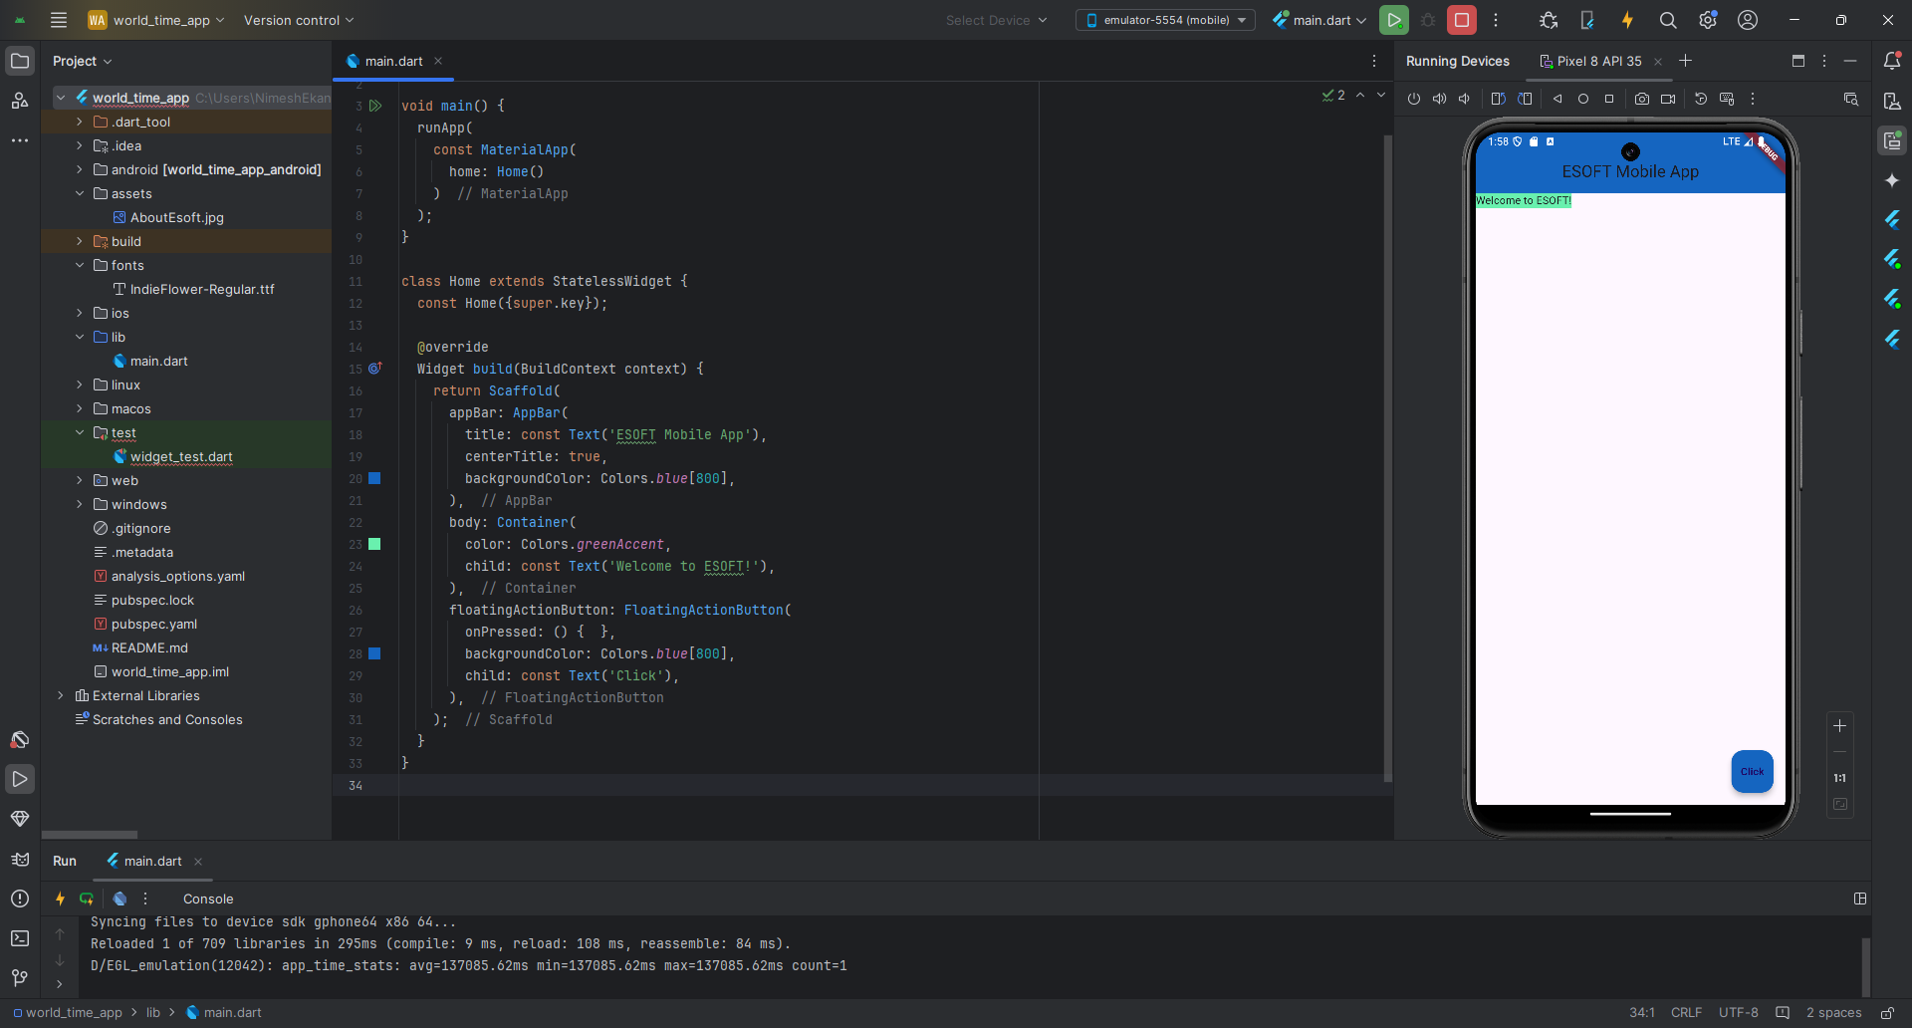

|  |
| --- |
|  |
| class Home extends StatelessWidget {  const Home({super.key});   @override  Widget build(BuildContext context) {  return Scaffold(  appBar: AppBar(  title: const Text('ESOFT Mobile App'),  centerTitle: true,  backgroundColor: Colors.*blue*[800],  ),  body: Container(  **padding: const EdgeInsets.all(20.0),**  color: Colors.*greenAccent*,  child: const Text('Welcome to ESOFT!'),  ),  floatingActionButton: FloatingActionButton(  onPressed: () { },  backgroundColor: Colors.*blue*[800],  child: const Text('Click'),  ),  );  } } |

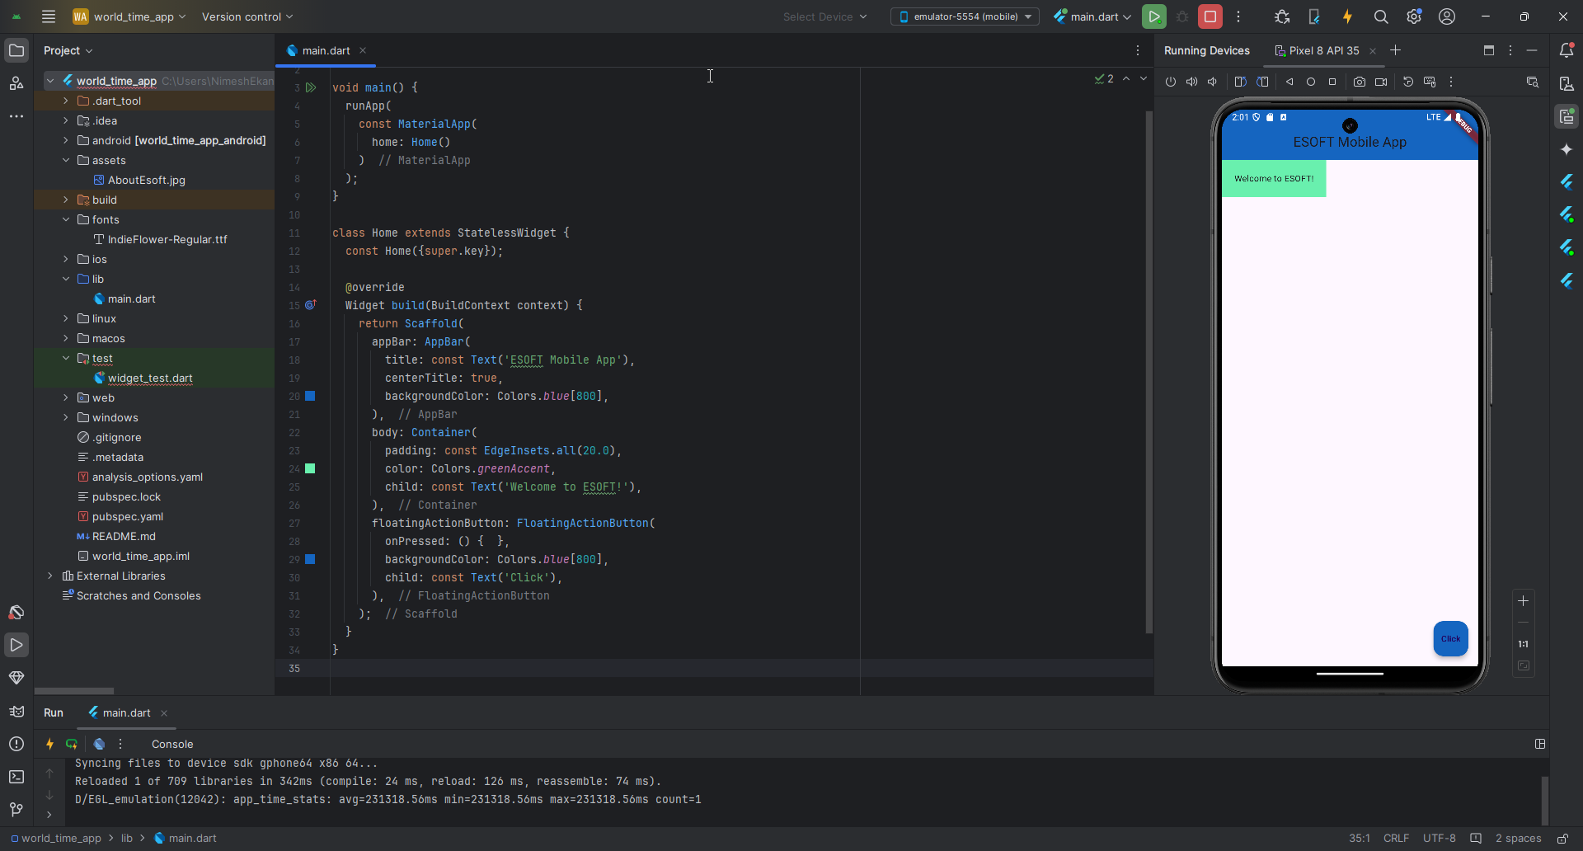

|  |
| --- |
|  |
| class Home extends StatelessWidget {  const Home({super.key});   @override  Widget build(BuildContext context) {  return Scaffold(  appBar: AppBar(  title: const Text('ESOFT Mobile App'),  centerTitle: true,  backgroundColor: Colors.*blue*[800],  ),  body: Container(  padding: const EdgeInsets.all(20.0),  **margin: const EdgeInsets.all(30.0),**  color: Colors.*greenAccent*,  child: const Text('Welcome to ESOFT!'),  ),  floatingActionButton: FloatingActionButton(  onPressed: () { },  backgroundColor: Colors.*blue*[800],  child: const Text('Click'),  ),  );  } } |

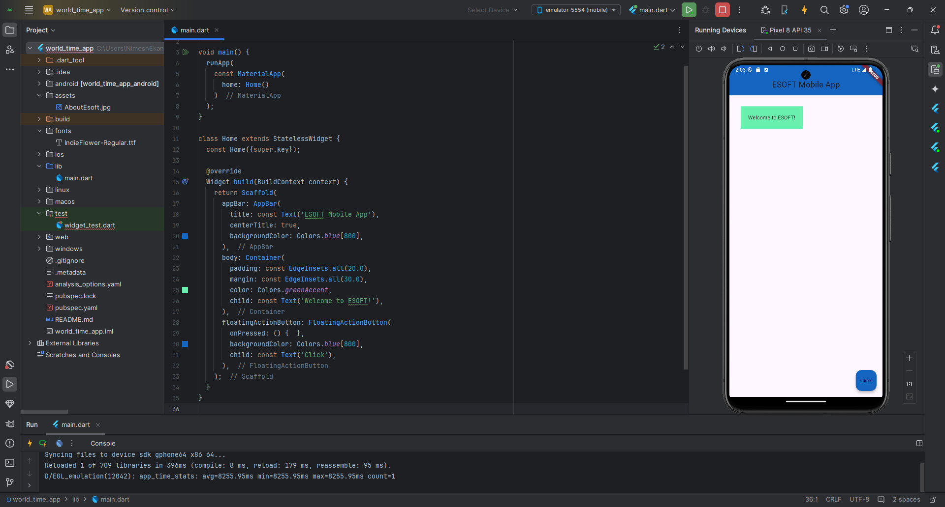

|  |
| --- |
|  |
| class Home extends StatelessWidget {  const Home({super.key});   @override  Widget build(BuildContext context) {  return Scaffold(  appBar: AppBar(  title: const Text('ESOFT Mobile App'),  centerTitle: true,  backgroundColor: Colors.*blue*[800],  ),  body: **const Padding(  padding: EdgeInsets.all(90.0),  child: Text('Padding Check...'),  ),**  floatingActionButton: FloatingActionButton(  onPressed: () { },  backgroundColor: Colors.*blue*[800],  child: const Text('Click'),  ),  );  } } |

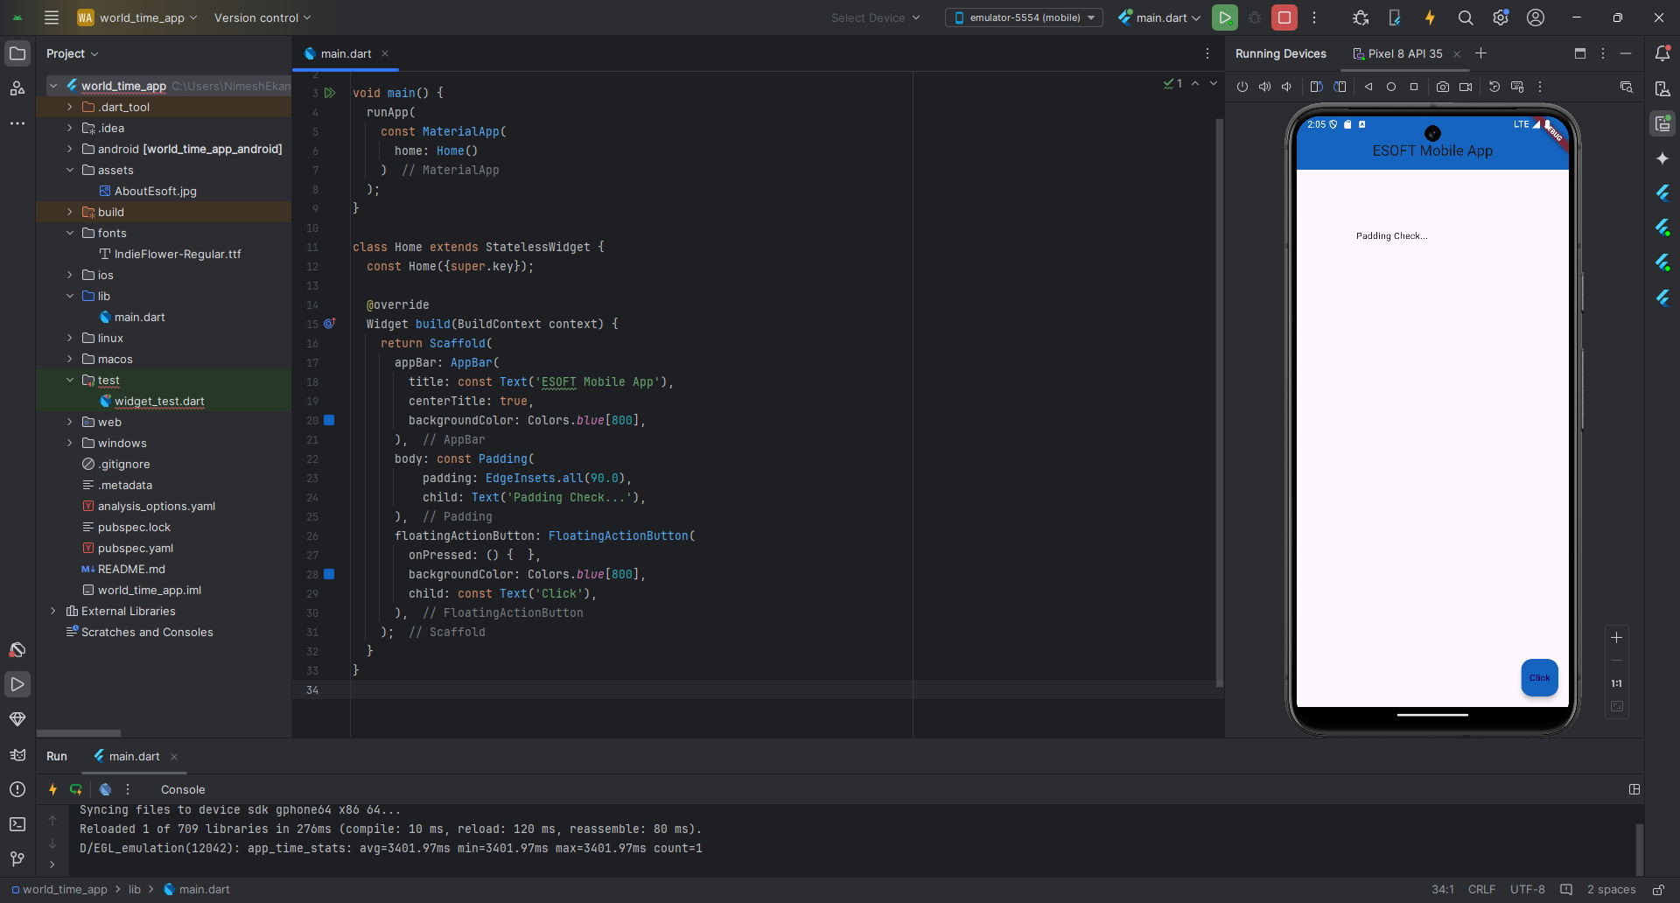

Rows

|  |
| --- |
|  |
| class Home extends StatelessWidget {  const Home({super.key});   @override  Widget build(BuildContext context) {  return Scaffold(  appBar: AppBar(  title: const Text('ESOFT Mobile App'),  centerTitle: true,  backgroundColor: Colors.*blue*[800],  ),  body: **Row(  children: [  const Text('Welcome to ESOFT!'),  TextButton(  onPressed: () {},   style: TextButton.*styleFrom*(  backgroundColor: Colors.*blueAccent*,  ),  child: const Text('Register Now'),  ),  Container(  color: Colors.*cyan*,  padding: const EdgeInsets.all(30.0),  child: const Text('Inside Container'),  )  ],  ),**  floatingActionButton: FloatingActionButton(  onPressed: () { },  backgroundColor: Colors.*blue*[800],  child: const Text('Click'),  ),  );  } } |

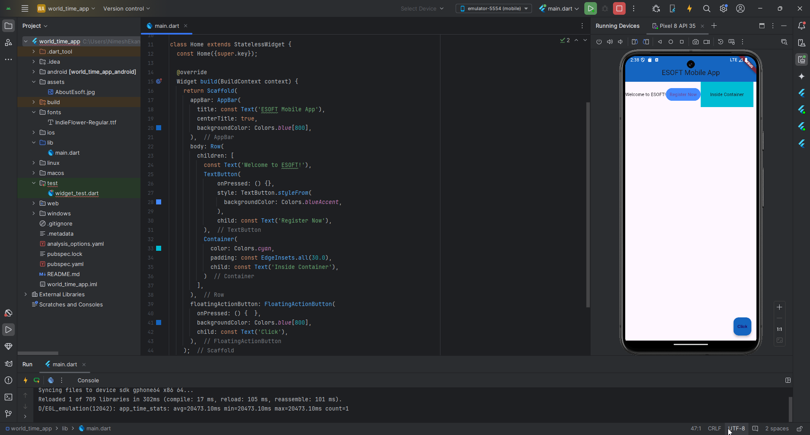

|  |
| --- |
|  |
| class Home extends StatelessWidget {  const Home({super.key});   @override  Widget build(BuildContext context) {  return Scaffold(  appBar: AppBar(  title: const Text('ESOFT Mobile App'),  centerTitle: true,  backgroundColor: Colors.*blue*[800],  ),  body: **Row(  mainAxisAlignment: MainAxisAlignment.spaceEvenly,  crossAxisAlignment: CrossAxisAlignment.start,  children: [  const Text('Welcome to ESOFT!'),  TextButton(  onPressed: () {},   style: TextButton.*styleFrom*(  backgroundColor: Colors.*blueAccent*,  ),  child: const Text('Register Now'),  ),**  Container(  color: Colors.*cyan*,  padding: const EdgeInsets.all(30.0),  child: const Text('Inside Container'),  )  ],  ),  floatingActionButton: FloatingActionButton(  onPressed: () { },  backgroundColor: Colors.*blue*[800],  child: const Text('Click'),  ),  );  } } |

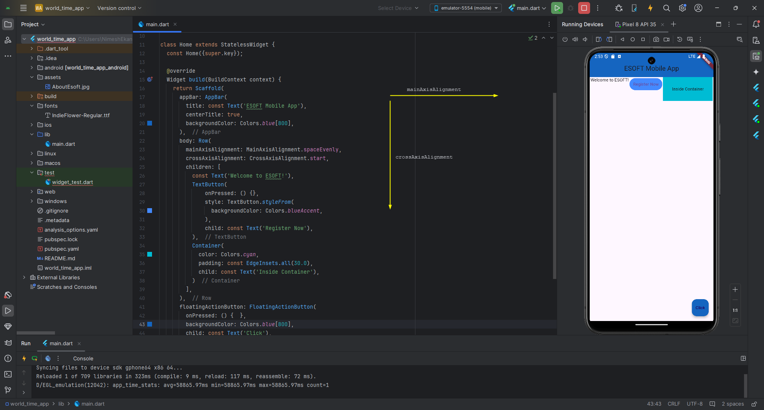

Columns

|  |
| --- |
|  |
| class Home extends StatelessWidget {  const Home({super.key});   @override  Widget build(BuildContext context) {  return Scaffold(  appBar: AppBar(  title: const Text('ESOFT Mobile App'),  centerTitle: true,  backgroundColor: Colors.*blue*[800],  ),  body: **Column(  children: [  Container(  padding: const EdgeInsets.all(20.0),  color: Colors.*amber*,  child: const Text('One'),  ),  Container(  padding: const EdgeInsets.all(30.0),  color: Colors.*blueAccent*,  child: const Text('Two'),  ),  Container(  padding: const EdgeInsets.all(40.0),  color: Colors.*greenAccent*,  child: const Text('Three'),  ),  ],  ),**  floatingActionButton: FloatingActionButton(  onPressed: () { },  backgroundColor: Colors.*blue*[800],  child: const Text('Click'),  ),  );  } } |

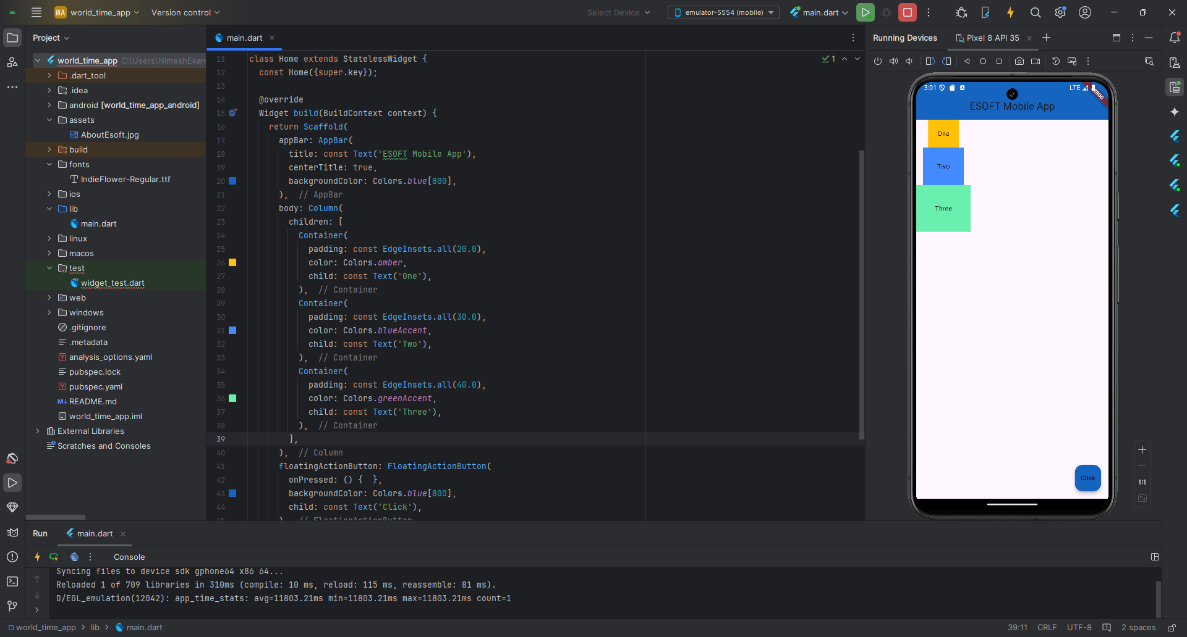

|  |
| --- |
|  |
| class Home extends StatelessWidget {  const Home({super.key});   @override  Widget build(BuildContext context) {  return Scaffold(  appBar: AppBar(  title: const Text('ESOFT Mobile App'),  centerTitle: true,  backgroundColor: Colors.*blue*[800],  ),  body: **Column**(  **mainAxisAlignment: MainAxisAlignment.end,  crossAxisAlignment: CrossAxisAlignment.stretch,**  children: [  Container(  padding: const EdgeInsets.all(20.0),  color: Colors.*amber*,  child: const Text('One'),  ),  Container(  padding: const EdgeInsets.all(30.0),  color: Colors.*blueAccent*,  child: const Text('Two'),  ),  Container(  padding: const EdgeInsets.all(40.0),  color: Colors.*greenAccent*,  child: const Text('Three'),  ),  ],  ),  floatingActionButton: FloatingActionButton(  onPressed: () { },  backgroundColor: Colors.*blue*[800],  child: const Text('Click'),  ),  );  } } |

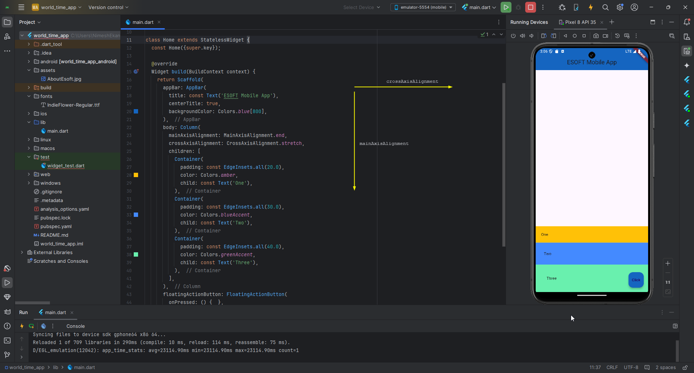

|  |
| --- |
|  |
| class Home extends StatelessWidget {  const Home({super.key});   @override  Widget build(BuildContext context) {  return Scaffold(  appBar: AppBar(  title: const Text('ESOFT Mobile App'),  centerTitle: true,  backgroundColor: Colors.*blue*[800],  ),  body: Column(  mainAxisAlignment: MainAxisAlignment.end,  crossAxisAlignment: CrossAxisAlignment.stretch,  children: [  **const Row(  children: [  Text('Hello '),  Text('World!'),  ],  ),**  Container(  padding: const EdgeInsets.all(20.0),  color: Colors.*amber*,  child: const Text('One'),  ),  Container(  padding: const EdgeInsets.all(30.0),  color: Colors.*blueAccent*,  child: const Text('Two'),  ),  Container(  padding: const EdgeInsets.all(40.0),  color: Colors.*greenAccent*,  child: const Text('Three'),  ),  ],  ),  floatingActionButton: FloatingActionButton(  onPressed: () { },  backgroundColor: Colors.*blue*[800],  child: const Text('Click'),  ),  );  } } |

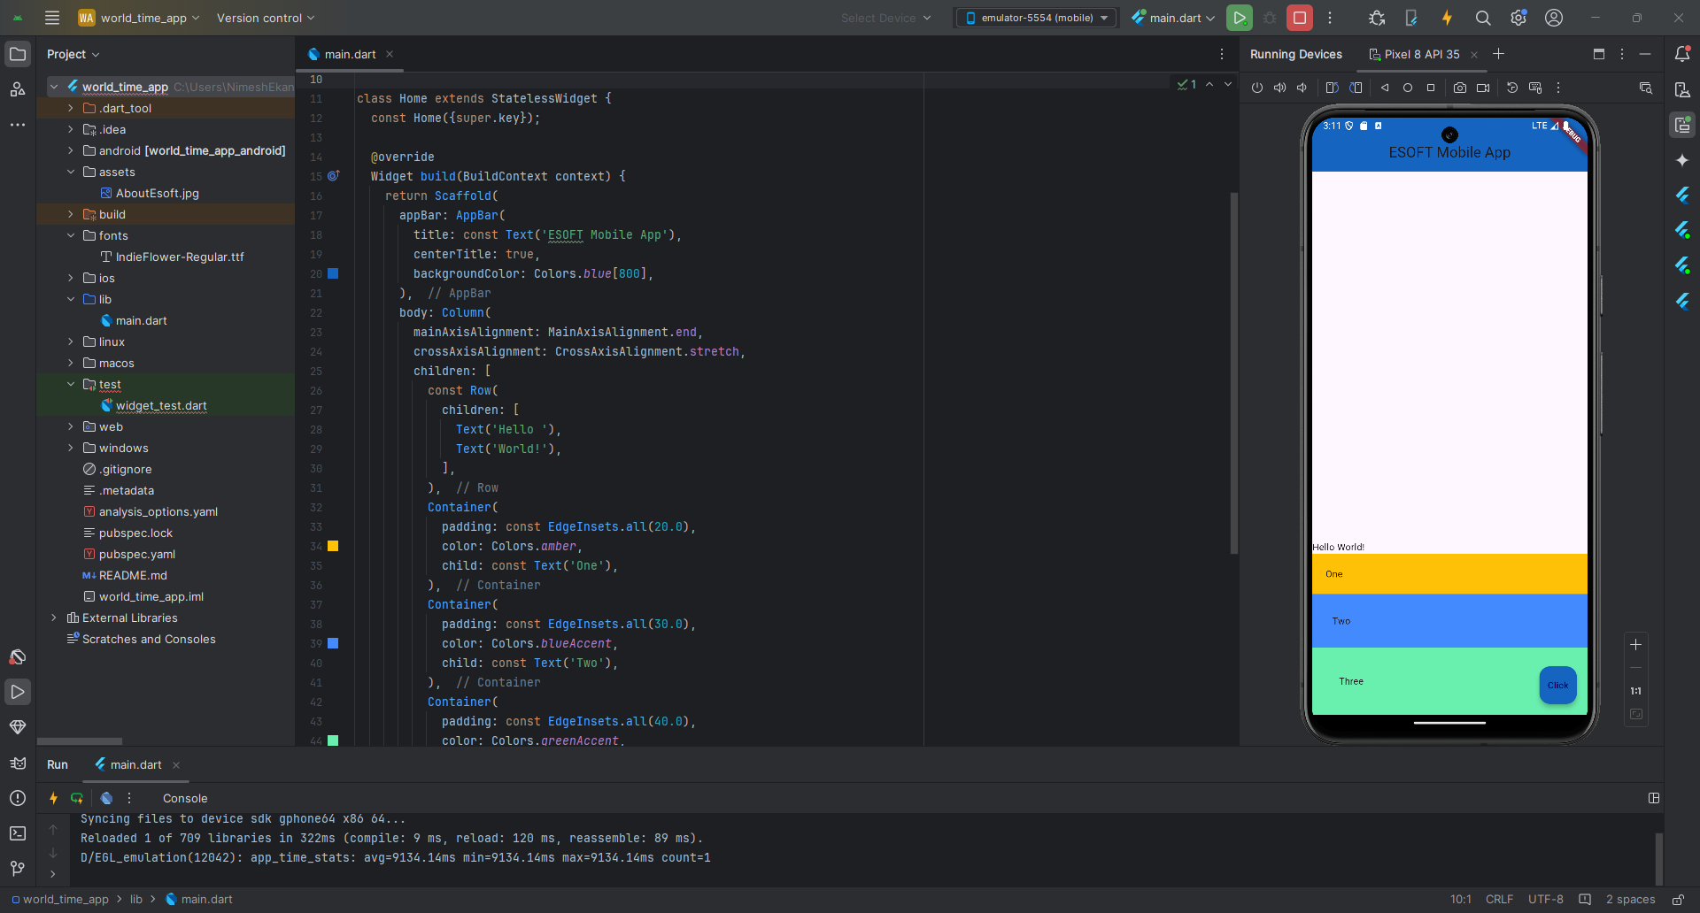

Expanded Widgets

|  |
| --- |
|  |
| class Home extends StatelessWidget {  const Home({super.key});   @override  Widget build(BuildContext context) {  return Scaffold(  appBar: AppBar(  title: const Text('ESOFT Mobile App'),  centerTitle: true,  backgroundColor: Colors.*blue*[800],  ),  body: Row(  children: [  **Expanded**(  child: Container(  padding: const EdgeInsets.all(30.0),  color: Colors.*cyan*,  child: const Text('1'),  ),  ),  **Expanded**(  child: Container(  padding: const EdgeInsets.all(30.0),  color: Colors.*amber*,  child: const Text('2'),  ),  ),  Container(  padding: const EdgeInsets.all(30.0),  color: Colors.*greenAccent*,  child: const Text('3'),  ),  ],  ),  floatingActionButton: FloatingActionButton(  onPressed: () { },  backgroundColor: Colors.*blue*[800],  child: const Text('Click'),  ),  );  } } |

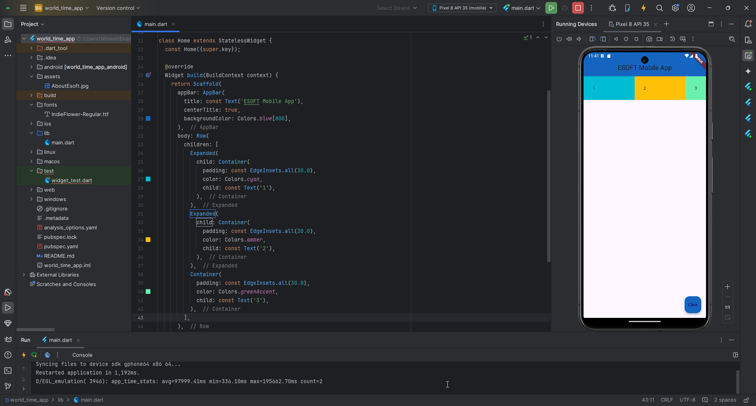

|  |
| --- |
|  |
| class Home extends StatelessWidget {  const Home({super.key});   @override  Widget build(BuildContext context) {  return Scaffold(  appBar: AppBar(  title: const Text('ESOFT Mobile App'),  centerTitle: true,  backgroundColor: Colors.*blue*[800],  ),  body: Row(  children: [  Expanded(  **flex: 3,**  child: Container(  padding: const EdgeInsets.all(30.0),  color: Colors.*cyan*,  child: const Text('1'),  ),  ),  Expanded(  **flex: 2,**  child: Container(  padding: const EdgeInsets.all(30.0),  color: Colors.*amber*,  child: const Text('2'),  ),  ),  Expanded(  **flex: 1,**  child: Container(  padding: const EdgeInsets.all(30.0),  color: Colors.*greenAccent*,  child: const Text('3'),  ),  ),  ],  ),  floatingActionButton: FloatingActionButton(  onPressed: () {},  backgroundColor: Colors.*blue*[800],  child: const Text('Click'),  ),  );  } } |

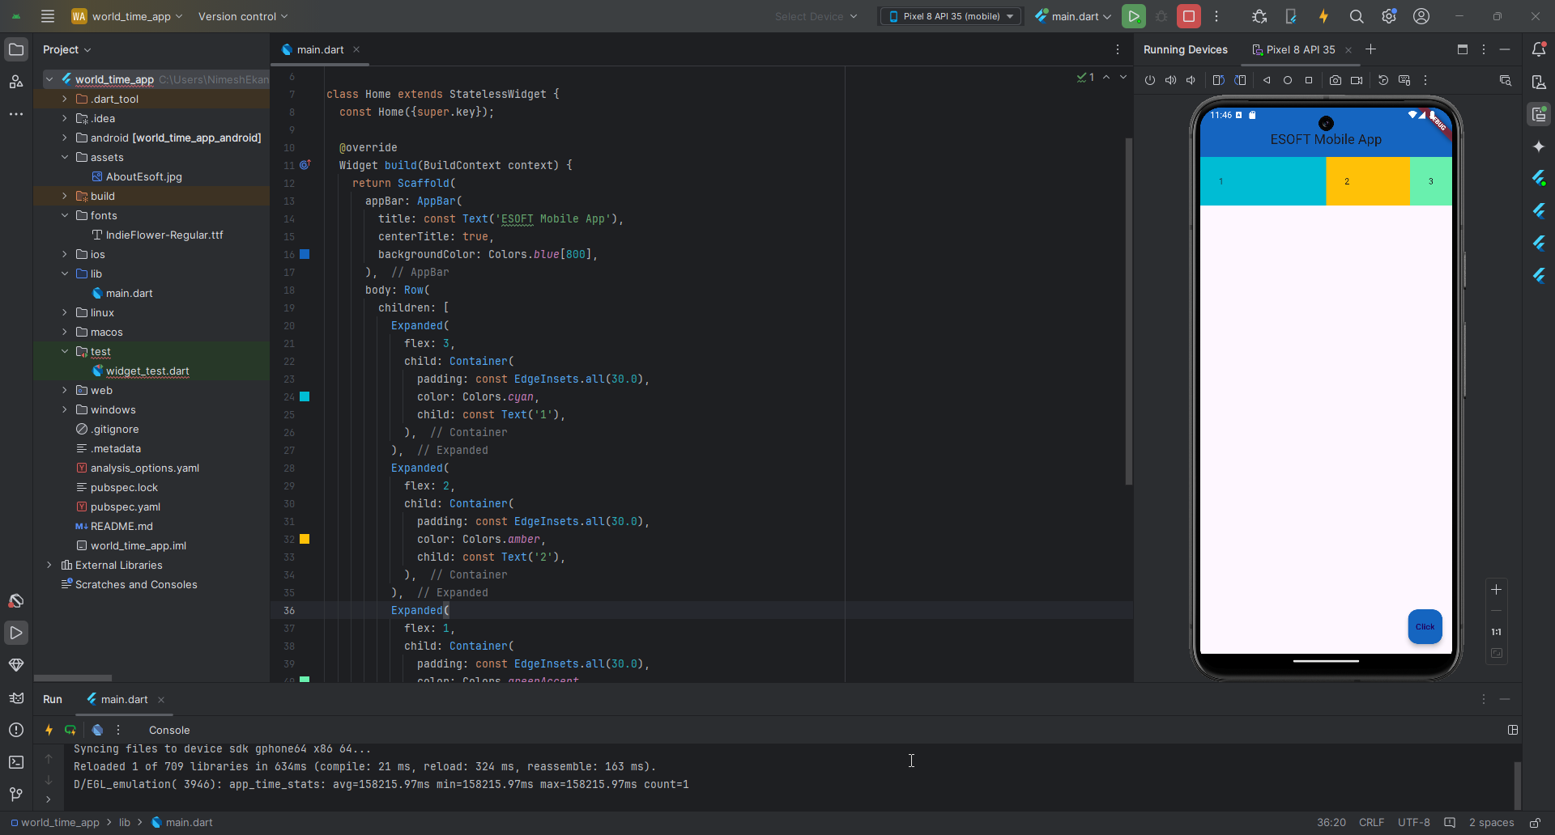

|  |
| --- |
|  |
| class Home extends StatelessWidget {  const Home({super.key});   @override  Widget build(BuildContext context) {  return Scaffold(  appBar: AppBar(  title: const Text('ESOFT Mobile App'),  centerTitle: true,  backgroundColor: Colors.*blue*[800],  ),  body: Row(  children: [  **Image.asset('assets/AboutEsoft.jpg'),**  Expanded(  flex: 1,  child: Container(  padding: const EdgeInsets.all(30.0),  color: Colors.*cyan*,  child: const Text('1'),  ),  ),  Expanded(  flex: 1,  child: Container(  padding: const EdgeInsets.all(30.0),  color: Colors.*amber*,  child: const Text('2'),  ),  ),  Expanded(  flex: 1,  child: Container(  padding: const EdgeInsets.all(30.0),  color: Colors.*greenAccent*,  child: const Text('3'),  ),  ),  ],  ),  floatingActionButton: FloatingActionButton(  onPressed: () {},  backgroundColor: Colors.*blue*[800],  child: const Text('Click'),  ),  );  } } |

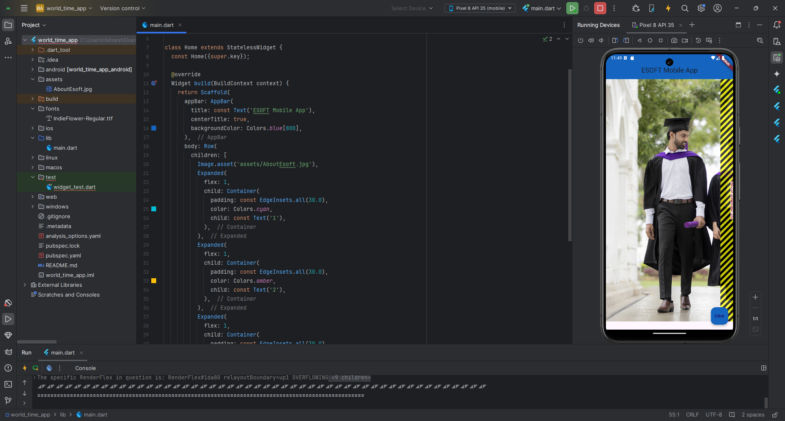

|  |
| --- |
|  |
| class Home extends StatelessWidget {  const Home({super.key});   @override  Widget build(BuildContext context) {  return Scaffold(  appBar: AppBar(  title: const Text('ESOFT Mobile App'),  centerTitle: true,  backgroundColor: Colors.*blue*[800],  ),  body: Row(  children: [  **Expanded(  flex: 3,  child: Image.asset('assets/AboutEsoft.jpg')  ),**  Expanded(  flex: 1,  child: Container(  padding: const EdgeInsets.all(30.0),  color: Colors.*cyan*,  child: const Text('1'),  ),  ),  Expanded(  flex: 1,  child: Container(  padding: const EdgeInsets.all(30.0),  color: Colors.*amber*,  child: const Text('2'),  ),  ),  Expanded(  flex: 1,  child: Container(  padding: const EdgeInsets.all(30.0),  color: Colors.*greenAccent*,  child: const Text('3'),  ),  ),  ],  ),  floatingActionButton: FloatingActionButton(  onPressed: () {},  backgroundColor: Colors.*blue*[800],  child: const Text('Click'),  ),  );  } } |

